1. Please build and install from driver source provided
2. Follow instructions in the "INSTALL" file

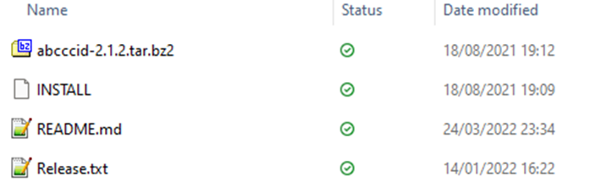

1. If libusb fails to install, please try to install with this line "sudo apt-get install libusb-1.0-0-dev"